**Jmeter-HTTP Request Default**

Step1: Add http request default to the test .

Add -> config element -> http request default

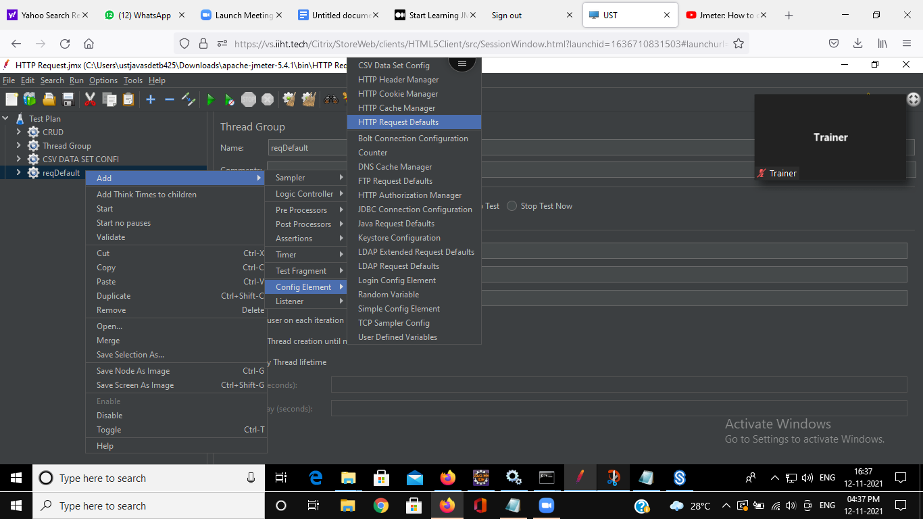

Step2: Add the default server.

Step3: Add multiple http requests.

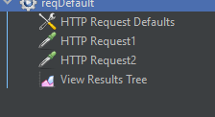

Step4: Give different paths to different http requests as required

Step5: add view result tree

Add -> listener ->view results tree

Step6: run the test

